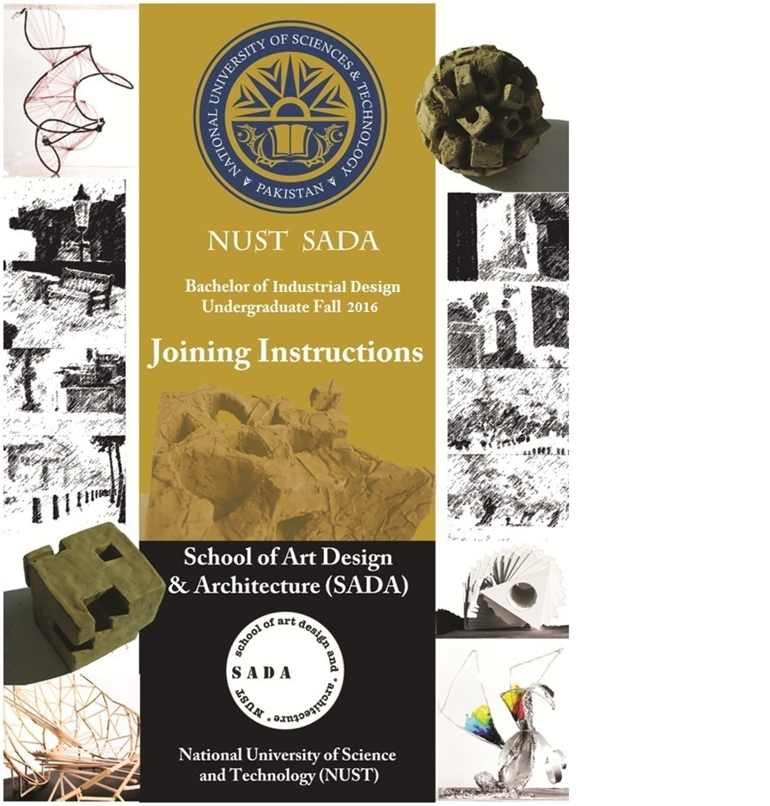

CONTENTS | PAGE NO
Introduction | --------------------------------------- 3
Location | --------------------------------------- 3
Arrival/Reception | --------------------------------------- 3
Dress Code/Outfit/Clothing | --------------------------------------- 4
General Information | --------------------------------------- 4
Documents | --------------------------------------- 7
Scholarships & Financial Assistance | --------------------------------------- 7
Surety Bond | --------------------------------------- 8
Undertaking | --------------------------------------- 9
Acknowledgement | --------------------------------------- 10

Introduction
Faculty and Staff of School of Art Design and Architecture (SADA) welcome you at National University of Science & Technology (NUST). The School of Architecture offers a four years course (eight semesters) leading to the Bachelor of Industrial Design (B. ID) Degree. The B. ID Degree course in the School of Architecture aims to prepare professional Designers, and students for advanced studies and research, through a comprehensive knowledge and skills in an intellectual and creative environment.
Graduates of the School would be absorbed in the profession and universities for higher education at the National and International level.
An overview of various aspects of training and administration is given to help you in settling down during the first few weeks at SADA.
Location
NUST/SADA is located in H-12 Sector, Islamabad and is approachable from Kashmir Highway (Joining Peshawar road and Murree road).
Arrival/Reception
An orientation program has been arranged for the students on 19 Sep, 2016 (Monday). The aim of this orientation is to facilitate new entrant’s integration in to the world of university with ease and confidence. New students are provided an opportunity right in the beginning to clarify doubts and concerns if any. The schedule of the day will be as under :-
- Reception 0930 Hours
- Collection of documents/ registration 1000 - 1200 hours
- Briefing 1205 - 1240 hours
- Welcome address by Principal SADA 1245 - 1300 hours
- Orientation visit of SADA 1400 hours onwards
Students who are desirous of availing hostel accommodation need to visit NUST website (www.nust.edu.pk) to apply as early as possible on prescribed form which may be downloaded. In case of inability to attend orientation program, the school must be informed telephonically on the numbers listed at the end of this document.

Dress Code/Outfit/Clothing
There is no specified uniform; however a proper dress code is to be followed, as specified below:
- MALE STUDENTS
- Dress Pants and dress shirts of decent color (Shorts or Bermudas not allowed).
- Simple jeans
- T-Shirt.
- Shalwar Kameez of decent color (Properly ironed).
- FEMALE STUDENTS
- Shirt with appropriate length and normal pattern Shalwar (Low neck and sleeveless shirts not allowed).
- Duppatta or Shawl (compulsory).
- Small heel or flat shoes (high heels not allowed).
- Trousers with long shirts (trousers with slits not allowed).
- DRESS CODE debars the following for the students.
- Wearing tight or see-through dress.
- Wearing shorts or sleeveless shirts.
- Wearing T-Shirts / dress bearing language or art, which appears to be provocative or indecent and is likely to offend others.
- Wearing shabby or torn clothing.
- Wearing jogging or exercise clothing during classes.
- Put on excessive makeup or wear expensive jewellery.
- Wearing untidy, gaudy or immodest dress in classrooms, cafeteria and university offices.
- Wearing unprofessional attire in formal programmes and interviews.
- Untidy Hair
General information
SADA provides an environment that supports both intellectual and personal growth. This requires striking a balance between upholding individual freedom and demanding respect for the rights of others. Each student has the right to pursue peacefully his / her study, and other students must respect this right.

As young adults, it may be your first or recent experience with certain freedom and privileges. The university should not therefore be constantly watching your actions or judging your behaviour. When your actions clash with the rights of others to a safe environment, the university considers it obligatory to intervene and preserve the academic rights of students as a community. You are therefore expected to demonstrate a high standard of conduct - one that is necessary to maintain the educational quality of the campus.

- Identity Cards
All students will be issued temporary identity cards on arrival. However, permanent NUST identity cards will be issued later. Students will be responsible for the safe custody of their identity cards. In case of loss or theft, they will be liable to disciplinary action.

- Accuracy of University Records

Students are expected to furnish accurate and complete information on all university forms and documents, including applications for admission and financial aid, references, local and home addresses and for other types of records. Provision of any inaccurate/ concealment of information may lead to termination from the institute.

- Discipline
Political activities are strictly forbidden on NUST/SADA premises, and all students are required to give a written undertaking at the time of admission that they will refrain from politics during their stay at school. RECTOR NUST has full powers to terminate the registration of a student found involved in political activities.

- Following practices are considered unacceptable for SADA students:

- Theft or damage to the property of school or of property of a member of school community or the property of a visitor to school or abetment to any of the above.

- Conduct that results in conviction of a crime or crimes in a court of competent jurisdiction may subject a student to disciplinary action including suspension or expulsion.

- Possession of firearms, explosives, dangerous chemicals or other weapons on SADA campus, or the display or use of the above to intimidate, frighten or control individuals.

- Engaging in conduct which obstructs or disrupts teaching, research, administration, disciplinary procedures, or other activities of the institute.

- Keeping pets/animals, cassette players etc or possessing any morally/religiously objectionable printed material.

- Using drugs and smoking on the Campus.

- Academic Dishonesty
SADA requires all students to adhere to high standards of integrity in their academic work. The school follows a zero-tolerance policy for activities such as plagiarism and cheating. Students found involved in such activities are subject to serious disciplinary action. This may include failure (F) grade by the instructor, academic suspension or expulsion.

- Unfair Means
Any Student found using unfair means or assisting another student during a test/examination shall be liable to disciplinary action. A student found guilty of such act by the institute Discipline Committee, shall be dealt with in the light of policy in vogue. Use of unfair means generally covers the following, namely;-
- An attempt to have access to the question paper before the test/examination.
- Use/possession of unauthorized reference material during test/examination.
- Any form of communication by the examinees with any one in or outside the examination room while the test/examination is in progress.
- Unauthorized entry into faculty’s office or that of his staff with the intention of having an access to or tempering with the official record/exam papers, etc.

- Leave
Students are required to get the leave sanctioned in advance on prescribed leave application form. No student is allowed to leave the classroom in anticipation. Leave application form is to be submitted only for genuine emergencies. However, 75% attendance is mandatory for the students to take a semester exam in taught subjects. Students are required to be present in the classrooms as per the training program. Those who join late or leave the classroom without permission will be marked absent.

Documents Required on Orientation Day
Students are required to bring along and deposit the following documents with the School Authorities on the day of orientation i.e 19 Sep, 2016.
- Original SSC / Equivalence Certificate and detailed Marks sheet, with 2x photocopies of each duly attested.
- Original HSSC / Equivalence Certificate and detailed Marks sheet, with 2x photocopies of each duly attested. (Must produce provisional equivalence certificate/ letter from IBCC if original equivalence is not issued so far)
- 2x attested photo-copies of CNIC or Form B and attested photo-copy of CNIC of father /guardian.
- 4x passport-size color photographs duly attested.
- 2x photographs for ID Cards (1” x 1” size)
- Medical fitness Certificate duly issued by a Registered Medical Practitioner doctor of any government hospital to the effect that the students is not suffering from any communicable disease, including Hepatitis, and is mentally / physically fit to undergo the course of studies. The certificate can be downloaded from our website.
- Surety Bond on stamped paper of Rs.100/- , duly attested by a Magistrate Class-I or Notary Public to the effect that the student will abide by all rules and regulations of the University, pay all fees / other dues as per schedule and will abstain from political activities during the entire course of study. Violation of content of the Surety Bond may lead to expulsion from the University. (Text of Surety Bond is attached with instructions).
- Undertaking by the student and parents/Guardian duly signed/counter signed.

- Acknowledgment Slip
All students are required to submit the acknowledgement slip (Specimen attached).

important telephone Numbers
For further information, please contact;
+92(0)51 90855406
+92(0)51 90855407
+92(0)51 90855401

Website: www.nust.edu.pk
NUST School of Art Design &Architecture
H-12 Sector, Islamabad

SURETY BOND
(Worth Rs 100/-)
(NUST STUDENTS)
1. KNOW ALL MEN BY THESE PRESENT THAT I, Mr./Ms.___________________________________________________________________(hereinafter called the trainee) and
Mr./Ms. _____________________________________________________________________________________(Surety No 1) and
Mr./Ms. ___________________________________________________(Surety No 2) (hereinafter called the sureties) do hereby bind ourselves and each of us and heirs, executors and administration to abide by the terms and conditions of NUST after having been selected against “civilian student of NUST” seat at NUST School of Art Design and Architecture (SADA).
2. During studies, the trainee shall abide by the school discipline and rules, regulations and standing orders/procedures concerned and pay all expenses in due time. Any violations of these will make the trainee liable to expulsion from the SADA, which shall be without right of appeal in any court of law. During studies, if trainee is expelled by the School on any ground, or deliberately fails and does not study, trainee will lose his seat in the School and will not be allowed to continue studies in any of the NUST institutions.
3. The trainee will abstain from any political activity during his tenure of studies at SADA. Trainee, if found guilty of an act which is forbidden by NUST/SADA authorities including cheating/drinking alcohol, etc, will be liable to expulsion from the SADA.
4. NUST (SADA) authorities reserve the right to plan/issue extended schedule of classes/exams during any part of the day, on as required basis.
Signature of the Student (Trainee): __________________________________

Surety No 1 (Father/Guardian) Surety No 2 (Any Class 1 Govt Servant)
Signature: _________________________ Signature: _____________________________
Name: _____________________________ Name: _________________________________
Son of: _____________________________ Son of: _________________________________
Designation/Status: ______________ Designation/Status: __________________
_____________________________________ _________________________________________
Address: __________________________ Address: _______________________________
_____________________________________ __________________________________________
Note: This bond will invariably be attested by Oath Commissioner/Notary Public.

UNDERTAKING
Peer Wadhai /
Faizabad
(By the Student & Parents/Guardian)

I, Mr./Ms. _________________________________________________________________________ son/daughter of Mr./Ms. __________________________________________________, student of B. Industrial Design course, hereby certify that I have read the joining instructions carefully and that during my stay with SADA, I shall be responsible to abide by the rules/regulations mentioned therein. I understand that I will be liable to appropriate disciplinary action for any misconduct or misbehavior.

Date: ____________ Signature: ___________________
Name: ______________________

COUNTERSIGNED BY PARENTS/GUARDIAN

Signature: _________________________________
Name:__________________________________

Address: __________________________________

Date:_______________ __________________________________

ACKNOWLEDGEMENT

1. I have received your Joining Instructions dated ____/_________/ 2016.

2. I will join SADA on due date __________________

OR

3. I cannot join due to the following reason:-

______________________________________________________________________________________________________________________________________________________________________________________________________________________________________________________________________________________________________________________________________________________________________________________________________________________________________________________________________________

4. I have/have not applied to Administration for the hostel accommodation.

Signatures___________________________
Name ____________ ________________
Address ___________________________
______________________________________

Note: Please detach & fill this proforma and send it immediately on the email address mentioned below
Email: exam@sada.nust.edu.pk

